Mobile Application Interface to Register Citizen Complaint
ABSTRACT
The day to day operations and functioning of the city is taken care by local governing bodies which are known as Government Authorities. Among many other things one of the most important responsibility of the Government Authorities is to manage and solve the complaints that the residents of the city might have. Now in order to maintain the large city requires that the Government Authority need to be aware of any problem or shortcoming either through (sensors/ CCTV cameras) or by allowing the citizens to complaint about these problems. The second option is usually preferred because it gives the proper valid information. A mechanism to accept the complaints from citizens of the city 24×7 times would be expectation from both the citizens of city and the Government Authorities (GA). The GA generally allows its citizens to register their complaint through several mediums. The chief modes of complaint registration is (a) by visiting the nearest Citizen Facilitation Centre (CFC) established by the Municipal Corporation where an officer listen to the complaints and asks some information and fills it in an electronic form. (b) By calling a contact centre, where the complaint is registered by a call centre agent by typing the complaint into electronic form, or (c) By filling in online complaint registration form i.e. through web portal. In this paper we purpose an Android Application Mobile interface which can be used to lodge complaints. The main idea is to make use of the existing web infrastructure and to provide an easy, cheap and quick mode of complaint registration. The proposed system will enable the citizens of city to lodge complaints anytime, anywhere.
EXISTING SYSTEM
There has been broad research in the area of e-services for municipal use. The idea is to understand the benefits, usability and utility of services that are provided by a city government using latest and better technologies. The web portal while allowing the users to lodge complaint has some serious constrains. The user is restricted to choose from among the list of predefined drop down list. This poses a major problem in the sense that the user tries to fit his complaint intone of the predefined drop downs. This results in a wrong fit and the complaint being directed to the wrong department which in turn affects the time taken to resolve the problem. The second major constraint is the need for the user to be aware of the ward number, additionally the user needs to have access to networked computer.
Disadvantages of Existing System:
- The normal people don’t have more internet connection with computer to usage of web portals.
- Complaints may submitted to other irrespective departments while submitting complaints in the portal
PROPOSED SYSTEM
The proposed mobile application interface emulates the functionality of the web portal based complaint filing system. The users use the mobile phone and do not need to access the web portal interface directly to file their complaint. The user runs the Application and can lodge complaint. Once all the information about complaint is entered by the user the application sends the information to server in a compatible format [as a HTTP (Hyper Text Transfer Protocol) request] to the server. Then the response from the server is fetched and is parsed to determine complaint number. The complaint number is then received by the user. This complaint number is then can be used by the user to generate the status of their complaint. But here the complaint is only registered when all the mandatory fields are filled.
Advantages of Proposed System:
- Mobile Application will help the citizen of a municipal corporation to register their complaints about day to day problems in their ward through a mobile application.
- Mobile Application will provide a common man to deliver his complaints and problems to municipal authority as well as let the municipal authorities to address the issue as soon as possible.
- The application provides an interface to register one’s complained and follow it up

SYSTEM ARCHITECTURE
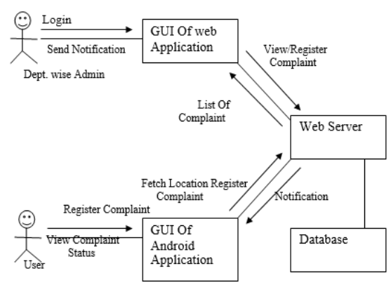
IMPLEMENTATION
In this project implementation we have 5 Modules
- Mobile Application
- Communication Network
- Server
- Global Positioning System (GPS)
- Camera
Module Description:
Mobile Application
Citizens will have mobile application .She/he can register a complaint related to specific zone where he/she finds a problem. Citizens can also embed an image with the complaint. This application can provide a user friendly UI interface. Mobile application contains GPS tracking system too.
Communication Network
Communication network is established in following areas by using some protocols: (a) Mobile application and server by using various protocols. (b) GPS satellite and mobile application. (c) Camera module and server.
Server
It contains request acceptance and processing system. It will contain specific UI for each department of Municipal Corporation for example Police, Traffic control etc. which will solve specific complaint related to that department only. Server module will accept the request and redirect it to department module after scrutinizing it. Received request can contain: (a) Image (not mandatory) (b) Text (mandatory) (c) GPS location (automatically generated)
Global Positioning System (GPS)
Along with these request application will embed the location from which request are getting placed. This is going to work by GPS tracking system. GPS devices are wireless and use satellites to enable users to detect the position of mobile on earth.
Camera
Mobile application is connected to camera module so that one can embed images with the complaints.
SYSTEM REQUIREMENTS
Hardware & Software Requirements:
- Android mobile with a minimum version 2.2
- Processor is not less than 500MHZ
- RAM is not less than 170MB
- SD card with minimum of 512MB
- Resolution is not less than 480*800pixs

